Our Team

Members :

Skills :

Laravel

Shopify

Joomla

Java Spring

Ionic

Angular

Marzipano

React Native

Node

MongoDB

CodeIgnitor

Opencart

Wordpress

Knack

Zapier

Portfolio Urls :

<http://consignatiekassa.be> : Laravel, Shopify

<https://letsgeton.be> : Laravel

<https://www.cdftravel.gr> : Joomla, Laravel

<https://www.fideicomisogds.mx> : Java Spring

<https://play.google.com/store/apps/details?id=com.latincargas.tmd> : React Native

<https://www.qinaya.app> : Laravel

<https://cannahope.suit.pe> : Node, Mongodb, Angular

<http://xtzart.net> : CodeIgniter

<https://cultrac.com> : Opencart

<https://jw.knack.com/eastside-lots> : Knack  
[http://mytemples.com/shop_profile/?uid=3](http://mytemples.com/shop_profile/?uid=3" \t "https://hh.ru/resume/_blank) : Wordpress   
[https://www.honestbeauty.com/](https://www.honestbeauty.com/" \t "https://hh.ru/resume/_blank) : Wordpress  
[http://weheartit.com/](http://weheartit.com/" \t "https://hh.ru/resume/_blank) : Wordpress  
[http://ronaldrichards.com](http://ronaldrichards.com/" \t "https://hh.ru/resume/_blank) : Laravel  
[http://www.shipsticks.com](http://www.shipsticks.com/" \t "https://hh.ru/resume/_blank) : Wordpress  
[http://deeplearningitalia.com](http://deeplearningitalia.com/" \t "https://hh.ru/resume/_blank) : Wordpress  
[http://theadventuresofchara.com](http://theadventuresofchara.com/" \t "https://hh.ru/resume/_blank) : Wordpress

[http://esl-ninja.com/Games](http://esl-ninja.com/Games" \t "https://hh.ru/resume/_blank) : PHP, Node  
[http://217.69.3.14:81](http://217.69.3.14:81/" \t "https://hh.ru/resume/_blank) : Laravel

You can get the images for above urls and insert it to bellow for portfolio images.

Bellow images are real site’s images and I have source code in my github.

Cryptocurrency Price Angular

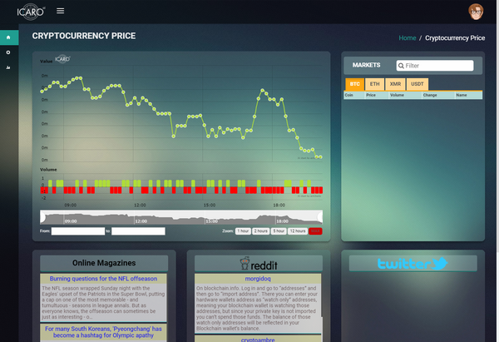

Healthy care ECG monitoring android app



Wordpress Website (Web design)

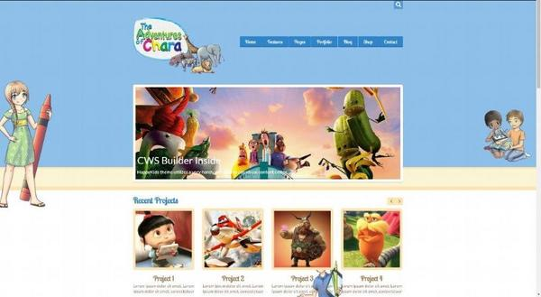

Wordpress Oneshopping Cart Website (Customize plugin)



Online board game (Node, PHP)

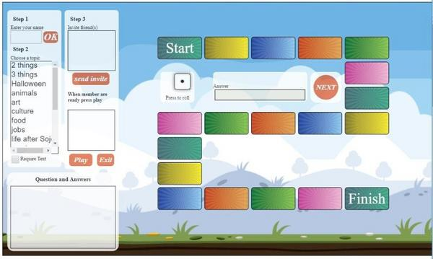

Image Editing Web application(VueJS)

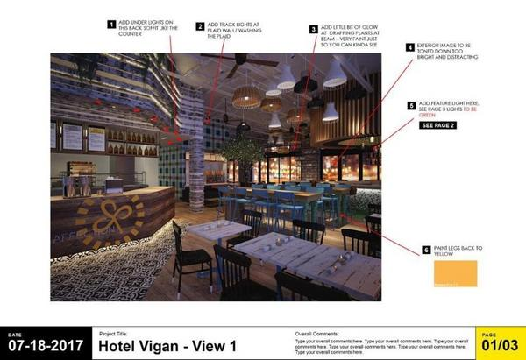

Bellow images are made by others.

Laravel, Shopify

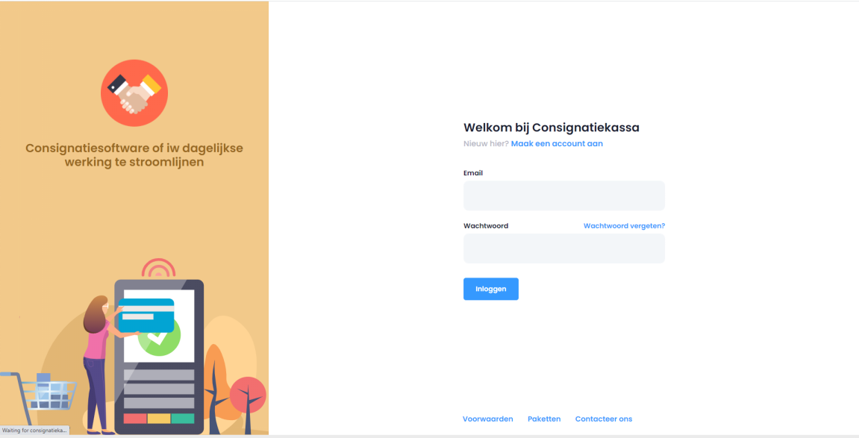

Laravel



Joomla, Laravel

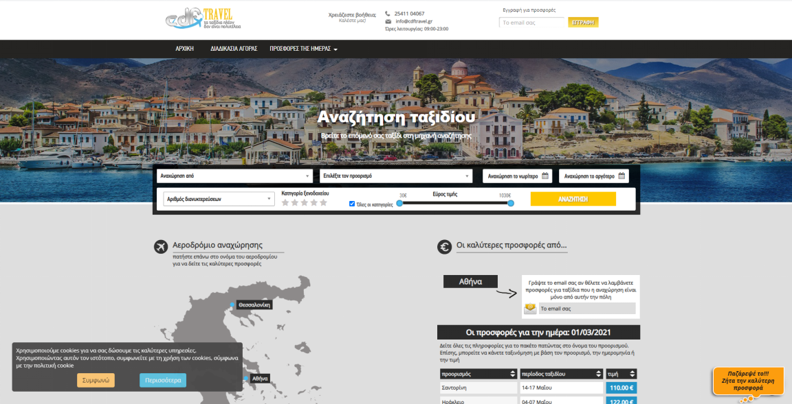

Java Spring



React Native



Laravel



Node, Mongo DB, Angular



CodeIgniter



OpenCart

